==================================================

Running Genetic Algorithm...

==================================================

==================================================

=== GENETIC ALGORITHM OPTIMIZATION ===

==================================================

[Initialization]

- Population size: 60

- Generations: 40

- Crossover rate: 80%

- Mutation rate: 20%

- Search space: 14 features

- Target: Minimize MSE using XGBoost

==================================================

=== OPTIMIZATION RESULTS ===

==================================================

▶ Best MSE achieved: 0.494339

▶ Time elapsed: 1110.28 seconds

▶ Features selected: 14/14 (0.0% reduction)

▶ Selected features:

1. 0

2. 1

3. 2

4. 3

5. 4

6. 5

7. 6

8. 7

9. 8

10. 9

11. 10

12. 11

13. 12

14. 13

▶ Convergence progress:

- Initial MSE: 0.4972

- Final MSE: 0.4943

- Improvement: 0.6%

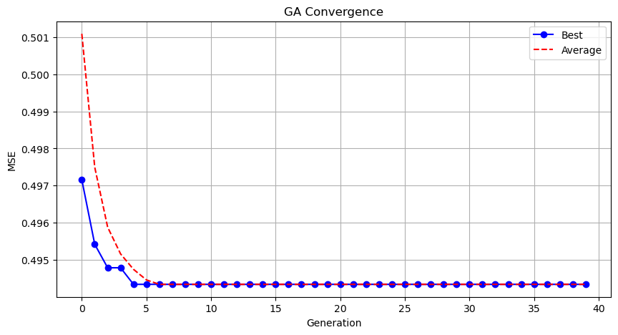

Genetic Algorithm completed successfully with MSE: 0.4943

==================================================

Running Particle Swarm Optimization...

==================================================

==================================================

=== PARTICLE SWARM OPTIMIZATION ===

==================================================

[Initialization]

- Swarm size: 60 particles

- Iterations: 40

- Cognitive weight: 0.5

- Social weight: 0.5

- Inertia weight: 0.5

- Search space: 14 features

- Target: Minimize MSE using XGBoost

==================================================

=== OPTIMIZATION RESULTS ===

==================================================

▶ Best MSE achieved: 0.494339

▶ Time elapsed: 1141.90 seconds

▶ Features selected: 14/14 (0.0% reduction)

▶ Selected features (with weights):

1. 0 (weight: 0.707)

2. 1 (weight: 0.688)

3. 2 (weight: 0.912)

4. 3 (weight: 0.579)

5. 4 (weight: 0.863)

6. 5 (weight: 0.864)

7. 6 (weight: 0.815)

8. 7 (weight: 0.551)

9. 8 (weight: 0.535)

10. 9 (weight: 0.641)

11. 10 (weight: 0.581)

12. 11 (weight: 0.681)

13. 12 (weight: 0.858)

14. 13 (weight: 0.528)

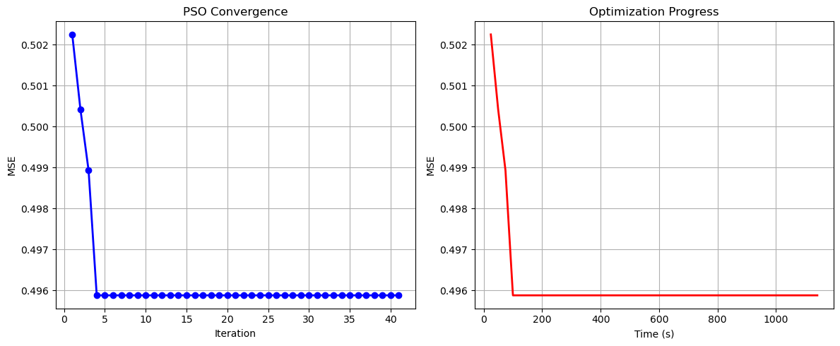

Particle Swarm Optimization completed successfully with MSE: 0.4943

==================================================

Running Whale Optimization...

==================================================

==================================================

=== WHALE OPTIMIZATION ALGORITHM ===

==================================================

[Initialization]

- Population: 60 whales

- Max iterations: 40

- Spiral coefficient (b): 1.0

- Search space: 14 features

- Target: Minimize MSE using XGBoost

[Optimization Progress]

Iter 40/40 | Best MSE: 0.494339

==================================================

=== OPTIMIZATION RESULTS ===

==================================================

▶ Best MSE achieved: 0.494339

▶ Time elapsed: 1085.60 seconds

▶ Features selected: 14/14 (0.0% reduction)

▶ Selected features:

1. 0

2. 1

3. 2

4. 3

5. 4

6. 5

7. 6

8. 7

9. 8

10. 9

11. 10

12. 11

13. 12

14. 13

▶ Convergence progress:

- Initial MSE: 0.5066

- Final MSE: 0.4943

- Improvement: 2.4%

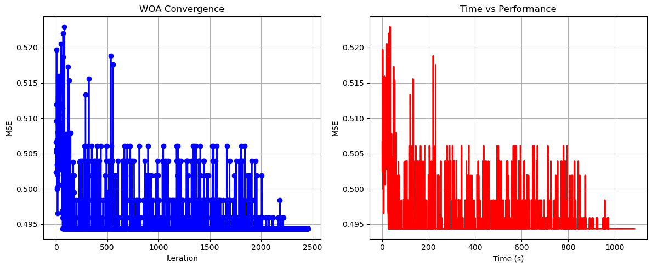

Whale Optimization completed successfully with MSE: 0.4943

==================================================

Running Squid Game Optimizer...

==================================================

==================================================

=== SQUID GAME OPTIMIZER (SGO) ===

==================================================

[Initialization]

- Players: 60 (30 offensive, 30 defensive)

- Max games: 40

- Search space: 14 features

- Target: Minimize MSE using XGBoost

==================================================

=== OPTIMIZATION RESULTS ===

==================================================

▶ Best MSE achieved: 0.494339

▶ Time elapsed: 1063.02 seconds

▶ Features selected: 14/14 (0.0% reduction)

▶ Selected features:

1. 0

2. 1

3. 2

4. 3

5. 4

6. 5

7. 6

8. 7

9. 8

10. 9

11. 10

12. 11

13. 12

14. 13

▶ Convergence progress:

- Initial MSE: 0.4973

- Final MSE: 0.4943

- Improvement: 0.6%

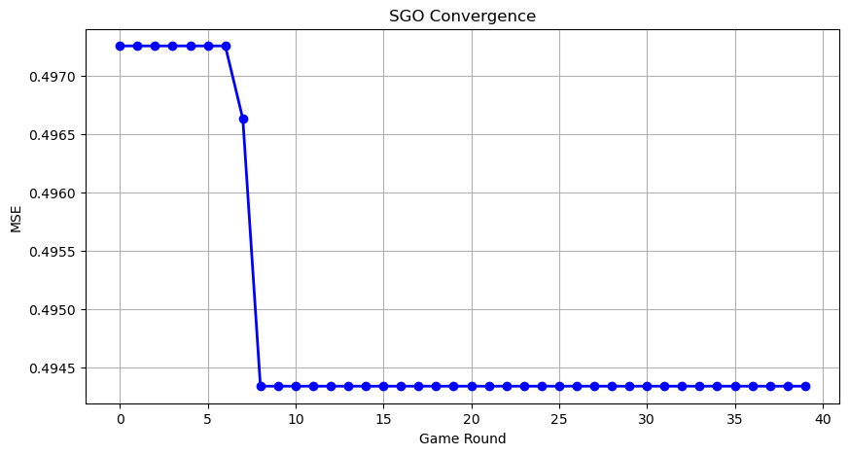

Squid Game Optimizer completed successfully with MSE: 0.4943

==================================================

Running PSH-Hyptrite...

==================================================

==================================================

=== PSH-HYPTRITE OPTIMIZATION ===

==================================================

[Initialization]

- Search points: 60

- Max iterations: 40

- Initial radius: 0.5 (adaptive)

- Hypersphere samples: 3 per point

- Search space: 14 features

- Target: Minimize MSE using XGBoost

[Optimization Progress]

Iter 40/40 | Best MSE: 0.494339 | Radius: 0.0125

==================================================

=== OPTIMIZATION RESULTS ===

==================================================

▶ Best MSE achieved: 0.494339

▶ Time elapsed: 3319.41 seconds

▶ Features selected: 14/14 (0.0% reduction)

▶ Selected features (with weights):

1. 0 (weight: 0.761)

2. 1 (weight: 0.868)

3. 2 (weight: 0.700)

4. 3 (weight: 0.671)

5. 4 (weight: 1.000)

6. 5 (weight: 0.523)

7. 6 (weight: 0.763)

8. 7 (weight: 0.705)

9. 8 (weight: 0.562)

10. 9 (weight: 0.797)

11. 10 (weight: 0.819)

12. 11 (weight: 0.726)

13. 12 (weight: 0.616)

14. 13 (weight: 0.533)

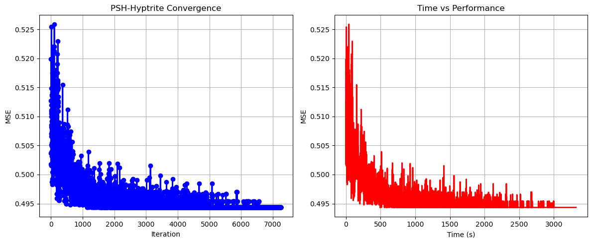

PSH-Hyptrite completed successfully with MSE: 0.4943

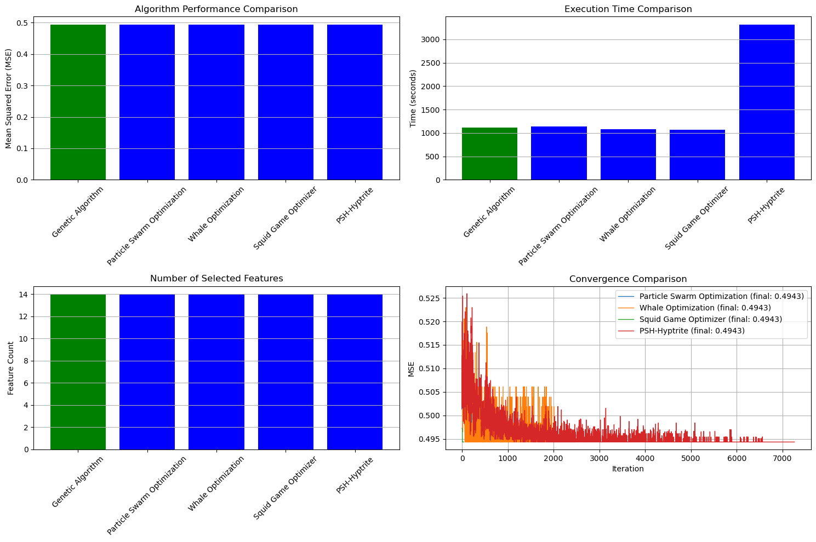

==================================================

FINAL RESULTS SUMMARY

==================================================

🏆 Best Algorithm: Genetic Algorithm

📉 Best MSE Achieved: 0.494339

⏱️ Execution Time: 1110.28 seconds

🔢 Features Selected: 14

Selected Features:

1. 0

2. 1

3. 2

4. 3

5. 4

6. 5

7. 6

8. 7

9. 8

10. 9

11. 10

12. 11

13. 12

14. 13